MID Semester Material
20 Oktober 2016
7:30

- Response Frequency & Phase response
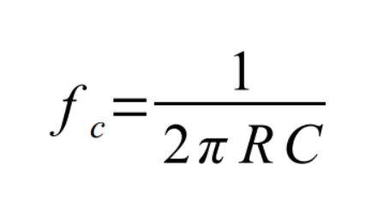

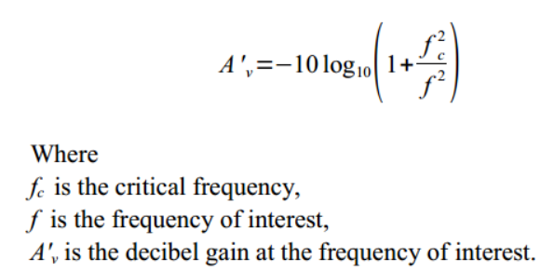

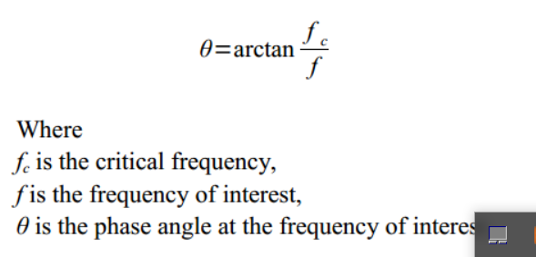

http://www.electronics-tutorials.ws/amplifier/frequency-response.html

- Operational Amplifier (Opamp) Basic Characteristic (Zi, Zo, Av, Zero Offset …. )
- Comparator (Circuit design)
http://www.electronics-tutorials.ws/tag/opamp/

Free-Ebook:
Operational Amplifiers & Linear Integrated Circuits (Ch-1, Ch-2)
Download from this link:
https://github.com/handaga/Analog-Circuit-Advance

